May 22, 2015 | Last Updated 7:49 AM

Loading

[](http://thenewage.co.za/home.aspx)[Follow](https://twitter.com/The_New_Age)

Image Loading

* [**Human remains found on farm**](http://www.thenewage.co.za/159824-1007-53-Human_remains_found_on_farm)
* [**â€˜We want all SAâ€™s children to read and writeâ€™**](http://www.thenewage.co.za/159823-1007-53-We_want_all_SAs_children_to_read_and_write)
* [**Struggle icon Andrew Mlangeni to mark 90th birthday with golf event**](http://www.thenewage.co.za/159822-1007-53-Struggle_icon_Andrew_Mlangeni_to_mark_90th_birthday_with_golf_event)
* [**More internal trading in Africa**](http://www.thenewage.co.za/159821-1007-53-More_internal_trading_in_Africa)
* [**International pressure on SA HIV-Aids investment**](http://www.thenewage.co.za/159819-1007-53-International_pressure_on_SA_HIVAids_investment)

[](http://thenewage.co.za/ratecard.pdf)

**Subscribe to newsletters**

[          ] *

http://www.thenewage.co.za/images/go-footer-btn.jpg

[MOBILE](http://thenewage.mobi/)[RSS](http://www.thenewage.co.za/rssfeed.aspx)[twitter](http://twitter.com/the_new_age)[facebook](https://www.facebook.com/pages/THE-NEW-AGE/138238556209769?sk=wall)

**You are here >** [**Home**](http://thenewage.co.za)**>  [News](http://thenewage.co.za) > National**

**National & Provincial**

May 21 2015 11:45PM

http://www.thenewage.co.za/images/star.gifhttp://www.thenewage.co.za/images/star.gifhttp://www.thenewage.co.za/images/star.gifhttp://www.thenewage.co.za/images/star.gifhttp://www.thenewage.co.za/images/star.gif

**˜We want all SA’s children to read and write™**

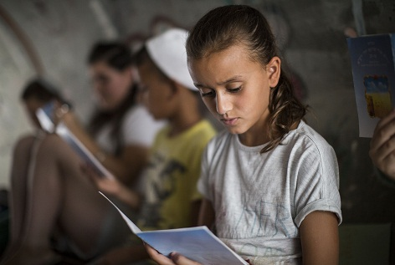

As South Africa struggles to address the backlog created by apartheid education, which marginalised the education of the black majority, a private company has come forward at Durban’s Anjuman Islamia Primary School to address the lack of resources.Picture:Getty Images

**[print](http://www.thenewage.co.za/printstroy.aspx?news_id=159823&mid=53)**

|  |
| --- |
| **Rate This Story** **close** |
| |  |  |  |  |  | | --- | --- | --- | --- | --- | | http://www.thenewage.co.za/images/SL1.gif | http://www.thenewage.co.za/images/SL2.gif | http://www.thenewage.co.za/images/SL2.gif | http://www.thenewage.co.za/images/SL2.gif | http://www.thenewage.co.za/images/SL2.gif | | http://www.thenewage.co.za/images/submit.jpg | | | | | |

http://www.thenewage.co.za/images/A-big.gif| http://www.thenewage.co.za/images/A-small.gif

 As South Africa struggles to address the backlog created by apartheid education, which marginalised the education of the black majority, a private company has come forward at Durban’s Anjuman Islamia Primary School to address the lack of resources.

The school has 690 pupils from Grade RR to Grade 7, most of whom come from informal settlements. About 160 of these pupils are from refugee families for whom English is a second language.

The school has a dedicated staff whose efforts have paid off – as underlined by the gradual improvement of the school’s performance in the Annual National Assessment (ANA).

However, the lack of library facilities has been a huge impediment in improving the children’s literacy rates.

The school is already using every square metre of the building, making the option of constructing a library impossible.

It recently approached Ahmed Motala of the New Africa Education Foundation for assistance after it completed a mobile library project for 20 schools in KwaMashu and this was considered a viable option for the Anjuman Islam Primary School. Motala approached the Willowton Group which has now stepped in to fund four mobile libraries for the school, at a total cost of R112000.

Deputy school principal Mohamed Akbar Aboobaker said the staff and pupils were elated with the libraries, each of which is stocked with 200 books covering a range of topics.

“This will go a long way in accelerating the literacy programme.There are 40 children per class and, because of the school’s design, it is difficult to move the children around easily,” he said.

Aboobaker said the mobile libraries are placed on each floor to cater for pupil’s needs.

Chairperson of Willowton Group, Farouk Moosa, said that a literate, educated society was a “safer, healthier and more prosperous society”.

He said the company wanted to promote a culture of reading and writing among children, which would lead to prosperity. “We, as a country, cannot afford to have children who cannot read and write, any longer.”

[provinces@thenewage.co.za](mailto:provinces@thenewage.co.za)

http://www.thenewage.co.za/images/A-big.gif| http://www.thenewage.co.za/images/A-small.gif