Sibaya eThekwini partnership donates Science kits to KZN schools
Underprivileged pupils will have the opportunity to excel in science.
Kerry Ibbetson | 4 September 2014
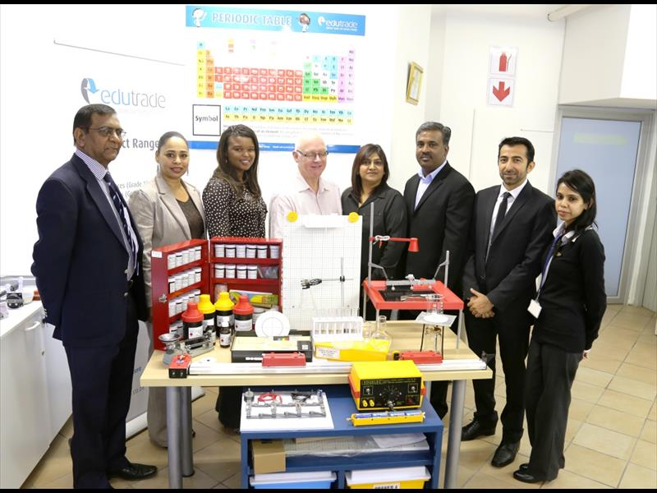
Moses Mogambery-Chief Education Specialist; Nareshini Ranganthan-CSI Manager Edu-Trade; Tsaone Mabelane-HR officer Sibaya; Jimmy Stewart-HR Manager Sibaya; Veena Naidoo – Co-ordinators Ethekwini Municipality; Les Subramoney -Director Edu-Trade; Amed Motala – New Africa Education Foundation and Ishani Vala-HR officer Sibaya.
Sixteen lucky schools in the Phoenix, Inanda and Kwa-Mashu areas will be the proud recipients of the latest CAPS compliant Edutrade Physical Science kits.
Sibaya Casino and Entertainment Kingdom in partnership with the eThekwini Municipality donated the kits to improve the learners’ performance in Science, Technology, and Engineering at school level so that more learners can pursue careers requiring these subjects at tertiary level.
Under the management of Sibaya Casino’s Corporate Social Investment committee an amount of R270 000 was provided to fund this project.
“A good education is founded on the premise that the environment be conducive to the practice of learning. It should be able to make available to learners the infrastructure, facilities and resources necessary for learning. Sadly, in South Africa the legacy of our past does not always render this basic fundamental a reality. All too often we find that our country’s schools – especially those serving the historically disadvantaged or today’s lower income groups – do not measure-up. Many fall short in terms of both infrastructure and the provision of the tools necessary to give effect to efficient teaching and effective learning and we hope that our contribution is a small step to making an improvement,” said Jimmy Stewart, Human Resources Manager of Sibaya Casino and Entertainment Kingdom.
As part of the initiatives aimed at addressing this challenge, the Municipality produced a video to be viewed by learners that demonstrate the work of an engineer, the different types of engineering career fields and higher education institutions which offer engineering courses.
“It is pleasing to see a public-private partnership in action, as private companies work together with government to fight these challenges. The science kits donated to the schools will go a long way in improving education in our country,” said Mr Linda Mbonambi, Ethekwini Municipality’s Area Based Manager: Phoenix, Inanda, Ntuzuma.

Read other articles with the same topics
durban engineering municipality physical science science kits Sibaya Casino underprivileged schools

