[NNews24 News. Breaking News. First](http://www.news24.com/" \o "News24.com Home)

**[Description: Description: http://pubads.g.doubleclick.net/gampad/ad?iu=/8900/24.com/Web/News24/SouthAfrica/Articles&sz=980x90&c=190000768&t=artid%3df4548230-3f1f-47d1-8cfe-aa5f21387032%26Places%3dpietermaritzburg%26Topics%3dlibrary%26accreditation%3dthe+witness%26posno%3d1](http://pubads.g.doubleclick.net/gampad/jump?iu=/8900/24.com/Web/News24/SouthAfrica/Articles&sz=980x90&c=190000768&t=artid%3df4548230-3f1f-47d1-8cfe-aa5f21387032%26Places%3dpietermaritzburg%26Topics%3dlibrary%26accreditation%3dthe+witness%26posno%3d1)**

**Mobile libraries and facilities for local underprivileged schools**

2015-10-21 08:34

Kailene Pillay, The Witness

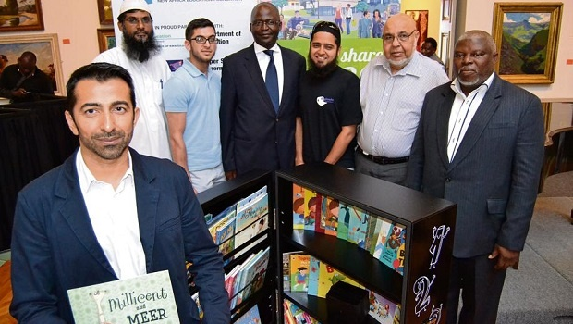

The Asifunde Mobile Library campaign was launched yesterday by the public and private sector at the Tatham Art Gallery. Pictured from left is Ahmed Motala (NAEF), Irshaad Amod (Nizamia Islamic School), Naasir Hoosen (Supersave), Mayor Chris Ndlela, M (Kailene Pillay)

[**Multimedia**](http://www.news24.com/Multimedia)   Â·   [**User Galleries**](http://www.news24.com/Multimedia/MyNews24)   Â·   [**News in Pictures**](http://www.news24.com/Multimedia/Category-Images) [**Send us your pictures**](http://uploads.news24.com?iframe)  Â·  **[Send us your stories](http://www.news24.com/FeedBack.aspx?iframe)**

Related Links

* [Youth show positivity in mural](http://www.news24.com/SouthAfrica/Local/Peoples-Post/Youth-show-positivity-in-mural-20151012)
* [Philippi library opens](http://www.news24.com/SouthAfrica/Local/City-Vision/Philippi-library-opens-20150930)
* [Msunduzi Top Model auditions to begin](http://www.news24.com/SouthAfrica/Local/Echo/Msunduzi-Top-Model-auditions-to-begin-20150923)

Pietermaritzburg - A unique collaboration between the public and private sector resulted in 10 deserving schools receiving mobile libraries and training facilities on Wednesday.

The Asifunde Mobile Library Campaign was launched in the city yesterday by CEO of New Africa Education Foundation Ahmed Motala at the Tatham Art Gallery.

The campaign has already seen 20 schools in the Phoenix, Inanda and KwaMashu areas receive the highly equipped mobile libraries.

Each mobile library costs R28 000.

**[Description: Description: http://pubads.g.doubleclick.net/gampad/ad?iu=/8900/24.com/Web/News24/SouthAfrica/Articles&sz=600x50&c=190000768&t=artid%3df4548230-3f1f-47d1-8cfe-aa5f21387032%26Places%3dpietermaritzburg%26Topics%3dlibrary%26accreditation%3dthe+witness%26posno%3d1](http://pubads.g.doubleclick.net/gampad/jump?iu=/8900/24.com/Web/News24/SouthAfrica/Articles&sz=600x50&c=190000768&t=artid%3df4548230-3f1f-47d1-8cfe-aa5f21387032%26Places%3dpietermaritzburg%26Topics%3dlibrary%26accreditation%3dthe+witness%26posno%3d1)**

The initiative was brought to Pietermaritzburg in a partnership between Willowton Oil, Nizamia Islamic School, Supersave, Hygienic Tissue Mills, the Department of Education and Msunduzi Municipality.

“This initiative is opening the doors of learning and culture and we need committed pupils to enter these doors. We are grateful to the good Samaritans who made this possible,” said Msunduzi Mayor Chris Ndlela yesterday.

Ndlela, a former high school principal, said he holds education very close to his heart.

Motala said the mobile libraries are an innovative way forward for less fortunate schools as the libraries can be wheeled to and from classrooms.

“A literate, educated society is a safer, healthier, and more prosperous society. So by promoting reading, writing and other academic subjects, it will lead the way in promoting prosperity through knowledge,” said Motala.

As part of Nizamia Islamic School’s corporate social responsibility, the school will assist with the training of teachers on the use of the resources so that maximum benefit is derived from this investment. The school will also make their facilities available for the underprivileged schools from time to time and some pupils from Nizamia Islamic School will also “twin” with the schools.

UMgungundlovu district manager Jennifer Baiju assisted with selecting the schools for this initiative.

They are

•Bruntville Primary - Mpofana

•Cebolesizwe Primary - Umshwathi

•Dlokwakhe Primary - Edendale

•Eastwood Primary - Pietermaritzburg

•Egalaji Primary - Mid-Illovu

•Magoda Primary - Inhlazuka

•Malunga Primary - Impendle

•Ondini Primary- Mid-Illovu

•Peter Pan Primary - Pietermaritzburg

•Emafakatini Primary - Impendle

The project will be co-ordinated and managed by Motala and it is envisaged that phase two of this project will target a further 10 schools in Pietermaritzburg

**Read more on:** [pietermaritzburg](http://www.news24.com/Tags/Places/pietermaritzburg)  |  [library](http://www.news24.com/Tags/Topics/library)

**[Description: Description: http://cdn.24.co.za/files/Cms/General/d/1/d7c46138d32c46a5811c42ffb492a3c5.jpg](http://www.witness.co.za/)**

**Join the conversation!**

24.com encourages commentary [submitted via MyNews24](http://uploads.news24.com/#story). Contributions of 200 words or more will be considered for publication.

We reserve editorial discretion to decide what will be published.   
[Read our comments policy](http://www.news24.com/MyNews24/YourStory/News24s-Comments-Policy-20101109) for guidelines on contributions.

NEXT ON NEWS24X

**[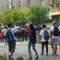](http://www.news24.com/SouthAfrica/News/National-protests-against-student-fees-20151021)**

[LIVE: Protesters bundled into police van in front of Parliament](http://www.news24.com/SouthAfrica/News/National-protests-against-student-fees-20151021)

2015-10-21 07:45