# Kwa Mashu schools receive mobile library donation during Library Week

**The education boost was introduced to assist the communities of Phoenix, Inanda, Ntuzuma and Kwa Mashu (PINK) areas.**

**March 25, 2015**

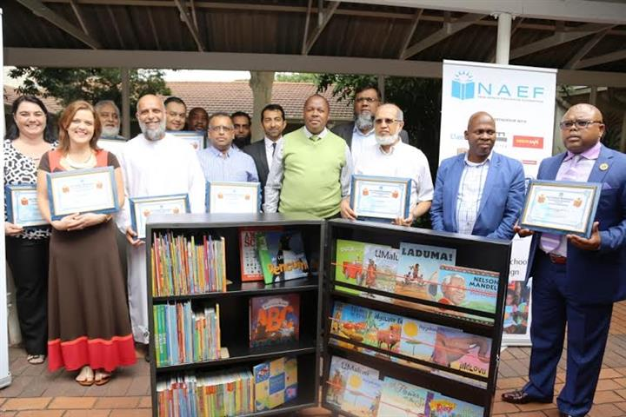

***Guests and role-players at the official handover.***

**Library Week did not go unmarked in the Phoenix and Kwa Mashu community after the eThekwini Municipality, Department of Education and local KwaZulu-Natal businessmen combined resources to introduce the Asifunde Mobile Library literacy campaign.**

**The education boost was introduced to assist the communities of Phoenix, Inanda, Ntuzuma and Kwa Mashu (PINK) areas.**

**Twenty lucky primary schools were the proud recipients of innovative mobile libraries which can be wheeled from one classroom to another. Many of the pupils come from communities which do not have libraries and it is shown that access to libraries improves pupil performance and increases their chances of success. Without proper resources there can be no equity to education and the value of this sponsorship amounts to R560, 000.**

**The Durban business community have opened their hearts and chequebooks to fund this project and they represent a diverse range of business houses many of whom are already involved in other educational projects such as Classic Trading luxury bathrooms, Desai Jadwat Incorporated, Freedom Stationery, Gem Schoolwear, Hypercheck Supermarket, Impress Printers, King Shaka International Airport-Airports Company South Africa (ACSA), Maytex Industries, MDLA Properties, Natal Box Manufacturers(NBF), and Pick n Win Supermarket.**

**Mr Ahmed Motala, CEO of New Africa Education Foundation, the NPO which is coordinating the project, said that the project could not have come at a better time. “A literate, educated society is a safer, healthier, and more prosperous society. So by promoting reading, writing, and other academic subjects, it will lead the way in promoting prosperity through knowledge. It is pleasing to see a public-private partnership in action, as private companies work together with government to fight these challenges. The mobile libraries donated to the schools will go a long way towards improving the literacy rate in our province,” Mr Motala added.**

**Alfalaah College, a private school based in Springfield, is also partnering in the project. “As part of Al-Falaah College’s corporate social responsibility, the school will assist with the training of teachers on the use of the resources so that maximum benefit is derived from this investment. It is envisaged that the school will also make available their facilities for the underprivileged schools from time to time and some pupils from Al-Falaah College will also ‘twin’ with the underprivileged schools,” said Ismail Dawood, a board member of the College.**

**eThekwini Municipality’s, Mr Linda Mbonambi, head of Area Based Management added, “A sound education provides pupils with the foundation necessary for life. It provides the vital tools which enable self-improvement, the ability to function within society, the ability to earn a living and to make a positive impact on the economy.” The municipality’s Library department will oversee and assist with the replenishment of books for the mobile libraries.**

**Mr NG Chonco, district director in Pinetown of the Department of Education and his team, assisted with the selection of schools and will also oversee the project.**

**The project will be co-ordinated and managed by Ahmed Motala of New Africa Education Foundation, and it is envisaged that phase two of this project will target a further 20 schools in the Umlazi district south of Durban.**

**SHARE**